Week 2

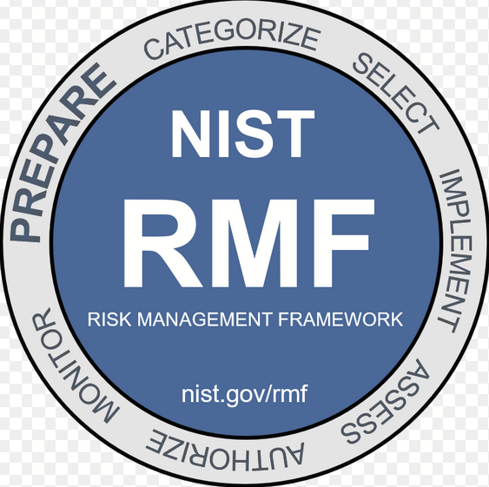

NIST CSF:

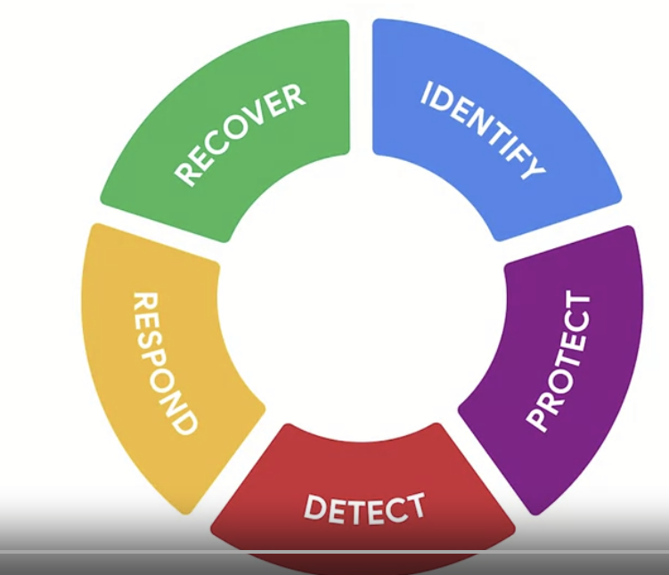

OWSAP Principles:

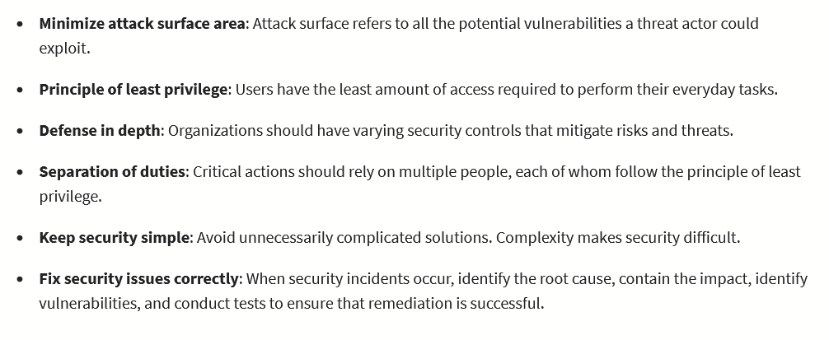

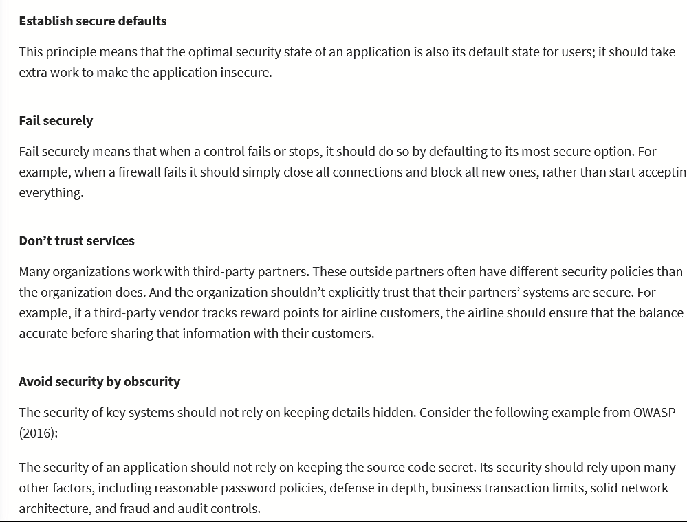

Security Audits:  
1.Define scope and goals of the audit

2.Risk assessment: threats, risks, vulnerabilities

3.Controls assessment: examining administrative, technical, and physical controls

4.Risk mitigation/compliance:

5.Communication of findings: how to improve, risks and priority, etc.

Week 3:

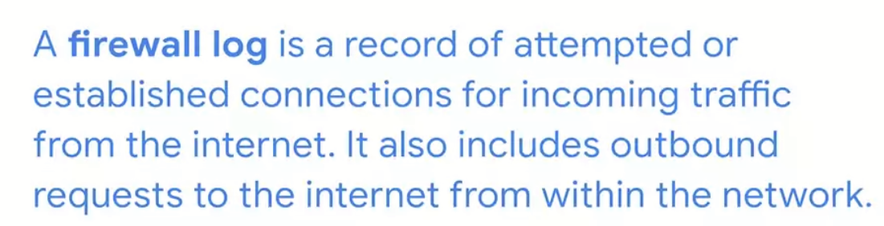

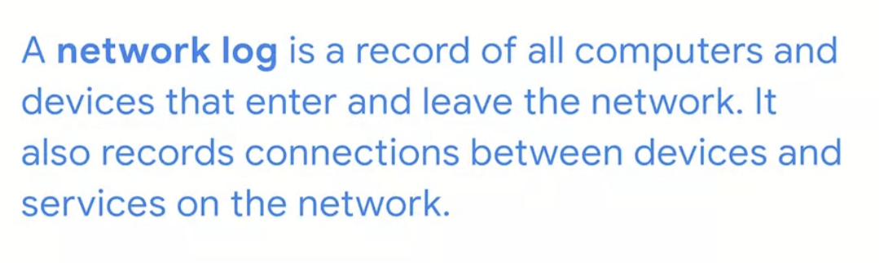

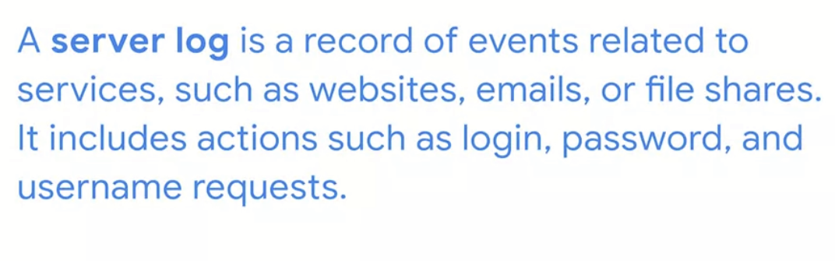

SIEM: Dynamic software, analyzes logs to reduce manual indexing of logs

